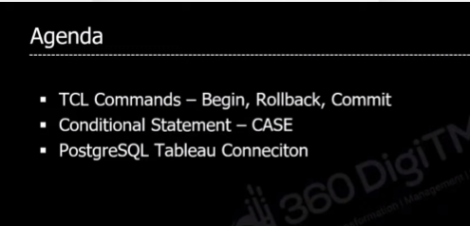

Tcl is transaction query language

More the one query are executed in single unit are called transaction. All the queries are run inside the begin block, that helps to track each and every command executed, with the help of this track we can do rollback

**Example for rollback:**

Consider we accidently runs the delete query which deleted no of row, this rollback are helps to retrieve those records with begin

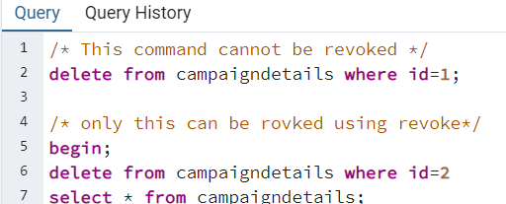

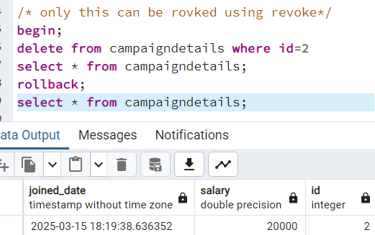

**Commit** is used to save the roll backed result.

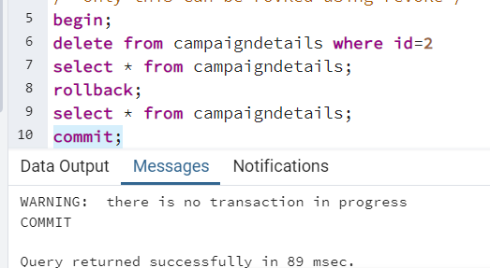

**DDL** commands **cannot be rollbacked**, only DML can be rollbacked.

**CASE:**

Helps to categorize a column’s value by specifying condition. Those conditions are given as when and then, else. If none of the conditions with when is not satisfied else will be executed

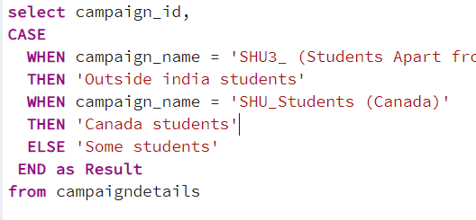

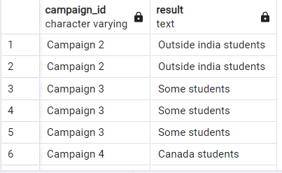

**Connection postgres to tableu**

[**SQL for Data Analytics & Data Science | Day-10 | 360DigiTMG**](https://www.youtube.com/watch?v=-y5Nm-0n62g&t=1662s) **(29:20)**